React Hitastic App: Component Design
The application should use three main components: App, Search and SearchResults. The App component manages the shared state, while the other components receive data and functions through props.

1. Component hierarchy diagram

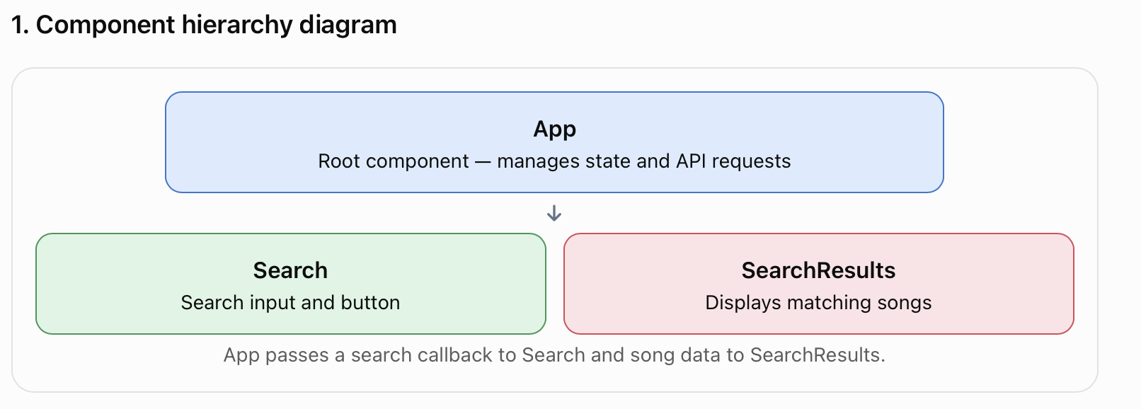

2. Components, sub-components and state
Component | Sub-components | State variables
App | Search, SearchResults | songs, searchResults, artist (optional), loading (optional)
Search | Search input, search button | searchTerm — the artist entered by the user
SearchResults | SongItem (one per song) | None required; receives results through props
SongItem | Song title, artist, year | None required
Important: Search does not need its own state if the search term is controlled by App. For this coursework, keeping the input state in Search and the results in App is also reasonable. Avoid storing the same information in multiple components unnecessarily.

3. Props received from the parent
Component | Props | Purpose
App | None | Root component
Search | onSearch | Callback function supplied by App
SearchResults | songs | Array of songs to display
SongItem | song | One song object containing title, artist and year
Example song object:
{
title: "I Am The Walrus",
artist: "The Beatles",
year: 1967
}

4. How lifting up state works

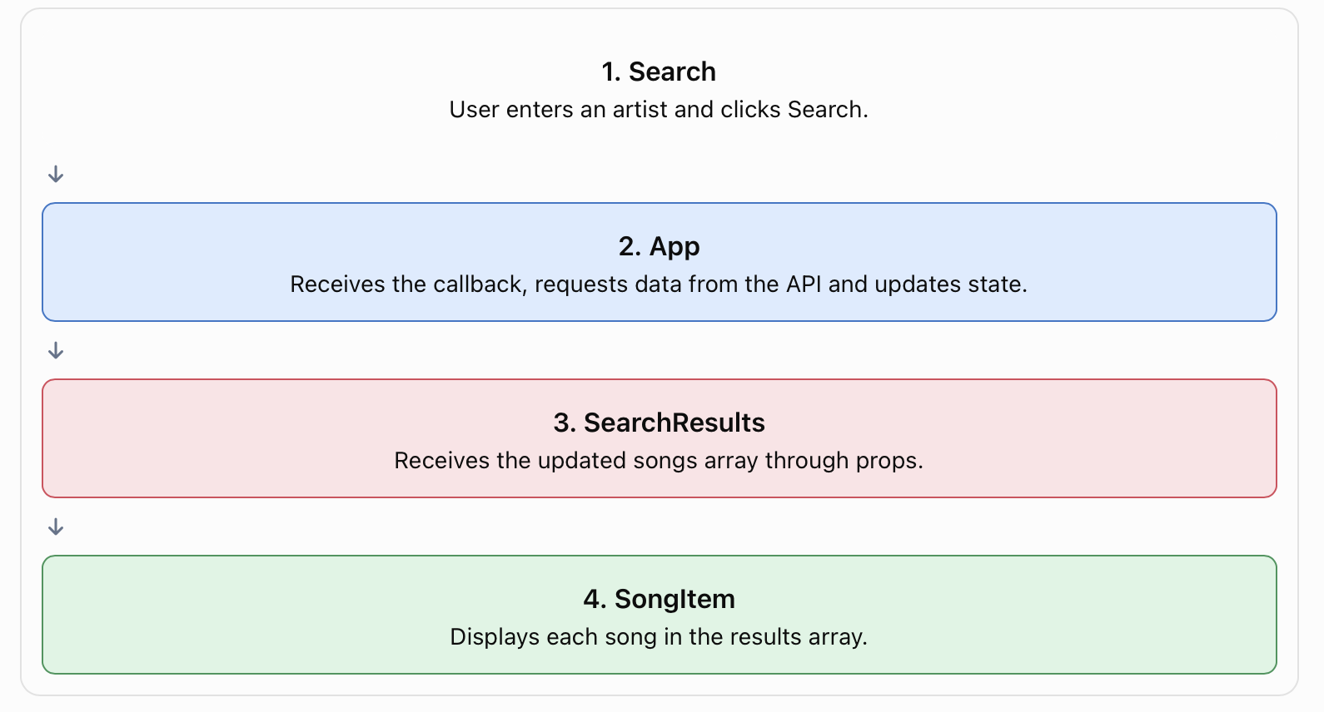

Example of the callback
In App:
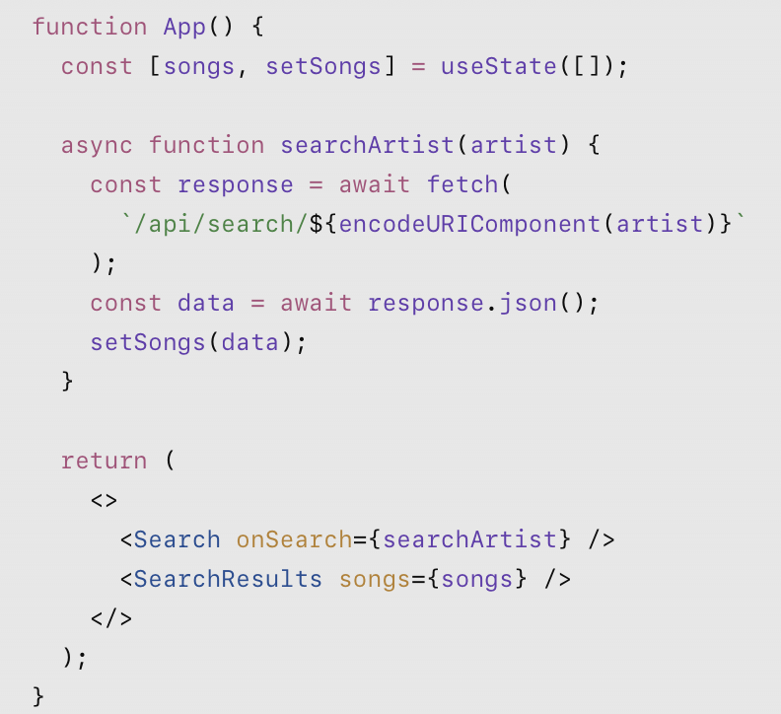
In Search:
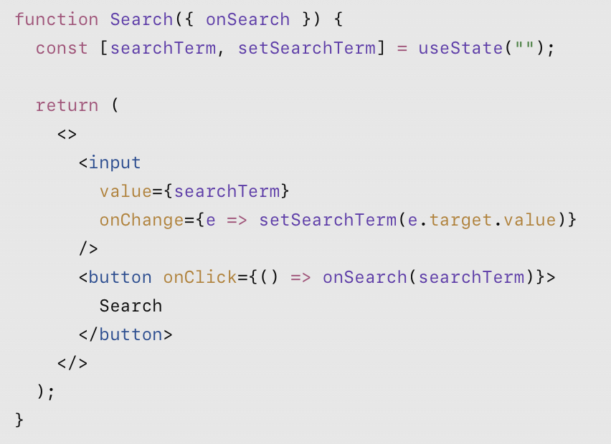

In SearchResults:
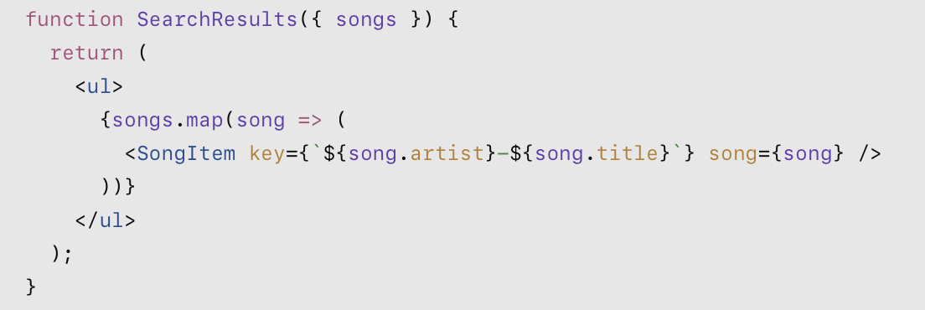
In SongItem:

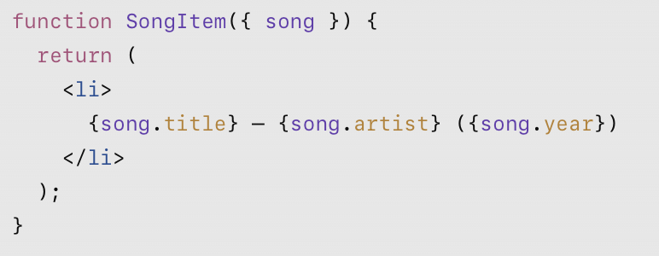

5. Key principle
Lifting up state means placing shared state in the nearest common parent component. Here, App owns the songs array because both the search operation and the results display depend on it. Search communicates user actions through a callback, while SearchResults receives the updated data through props.
This design separates responsibilities, reduces duplicated state and makes the components reusable.
Each area of the UI needs to be its own component. For example:
- Login component
- Search input component
- Search results component
- Add song component
The image below shows a more detailed analysis.
